Learning Journal Unit 2
Godfrey Ouma
University of the People
PSYC 1504: Introduction to Psychology
Lanier Wells
April 25, 2024

Question 1: Briefly describe the general structure and function of the nervous system.
The nervous system is subdivided into the central nervous system (CNS) and the peripheral nervous system (PNS), where the former is made up of the brain and spinal cord, while the latter is made up of nerves linking the CNS to the remaining parts of the body (Spielman et al., 2017). The CNS is made up of the brain and the spinal, which are in the skull and vertebral column respectively (SBCCOE, n.d). The PNS plays the role of exchanging information between the CNS and the muscles, organs, and senses in the periphery of the body. The PNS is subdivided into the somatic nervous system and the autonomic nervous system, which play the role of relaying sensory and motor information between the CNS and other parts of the body (Spielman et al., 2017). The somatic nervous system is made up of motor neurons and sensory neurons, where the former is tasked with sending messages between the CNS and muscles, while the latter relays sensory information to the CNS (Spielman et al., 2017). On the other hand, the autonomic nervous system is further subdivided into the sympathetic and parasympathetic systems, which play the role of preparing the body for stress-related activities and the parasympathetic restoring the body to normal state respectively (Spielman et al., 2017). Figure 1 illustrates the general structure of the human nervous system.
Figure 1:
The general structure of the human nervous system
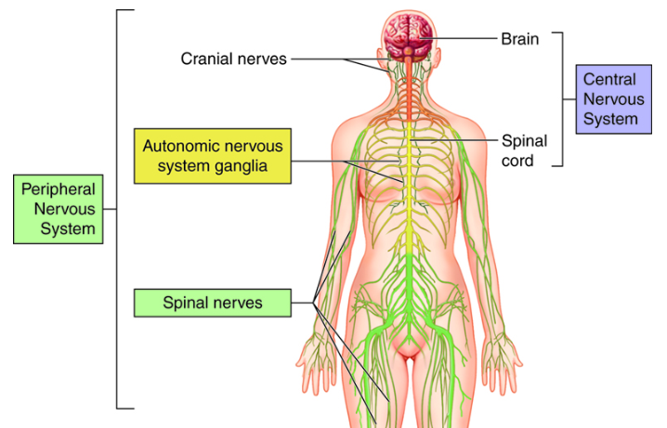
Question 2: Why is studying “sleep” important in a psychology course? What benefit does sleep provide to the nervous system and the body?
Psychology provides an avenue for scholars to learn different states of consciousness and understand the relationship between sleep and brain function. ​ Moreover, psychologists may need to understand the causes, symptoms, and treatments of sleep disorders and be able to explain their effects on ​ individuals' physical and mental health when dealing with their clients with similar concerns (Spielman et al., 2017). In addition, the close association between sleep and mental health conditions like depression, anxiety, and bipolar disorder necessitates the need to study sleep to understand the importance of adequate sleep as a potential solution. On the same note, psychologists need knowledge about sleep to understand better sleeping habits can be used as an intervention to optimize better working performance (Spielman et al., 2017). Therefore, is studying “sleep” important in a psychology course because knowledge of sleep helps to understand consciousness, brain function, mental health, physical health, and performance, which influence human behavior.
To understand the benefits of sleep to the nervous system and the body, it is important to note that sleep helps to eliminate toxins in the human brain that accumulate while staying awake. This happens when cerebrospinal fluid flows in spaces between membranes surrounding the brain and meninges, where it mixes with “interstitial fluid” within the brain to eliminate toxic waste products (Makin, 2019). A study by Rosado and Silva-Néto (2020) found that headaches the next day after the night shift were more prevalent among migraine patients. Going by this information, one may attribute chronic headaches after the night shift to a high accumulation of toxic wastes in the brain due to lack of sleep.
Question 3: Have you experienced sleep disturbances? If so, please explain the effects on your physical, mental, and emotional health.
Yes, which has been the main cause of my sleep deprivation. For instance, I may sleep as late as past midnight and still wake up at 4 am to study since I am also working full-time. The ideal sleeping hours for an adult is 7-9 hours (Spielman et al., 2017). However, sometimes I sleep for only 4 hours which is below the required sleeping hours for an adult. This short duration of sleep comes with repercussions such as feeling mentally exhausted, physically weak, chronic headaches, and mood swings.

References
Rosado, M. S., & Silva-Néto, R. (2020). Headache triggered by sleep deprivation: An observational study. Headache Medicine, 11(2), 44-47. https://doi.org/10.48208/headachemed.2020.13
SBCCOE. (n.d). Anatomy & physiology. Open Learning Initiative, Carnegie Mellon University. https://pressbooks.ccconline.org/bio106/chapter/nervous-system-levels-of-organization/
Spielman, R., Dumper, K., Jenkins, W., Lacombe, A., Lovett, M. & Perlmutter, M. (2017). Psychology. OpenStax College, Rice University.

